Mantid
PM report to Project Management Board
23rd November 2015
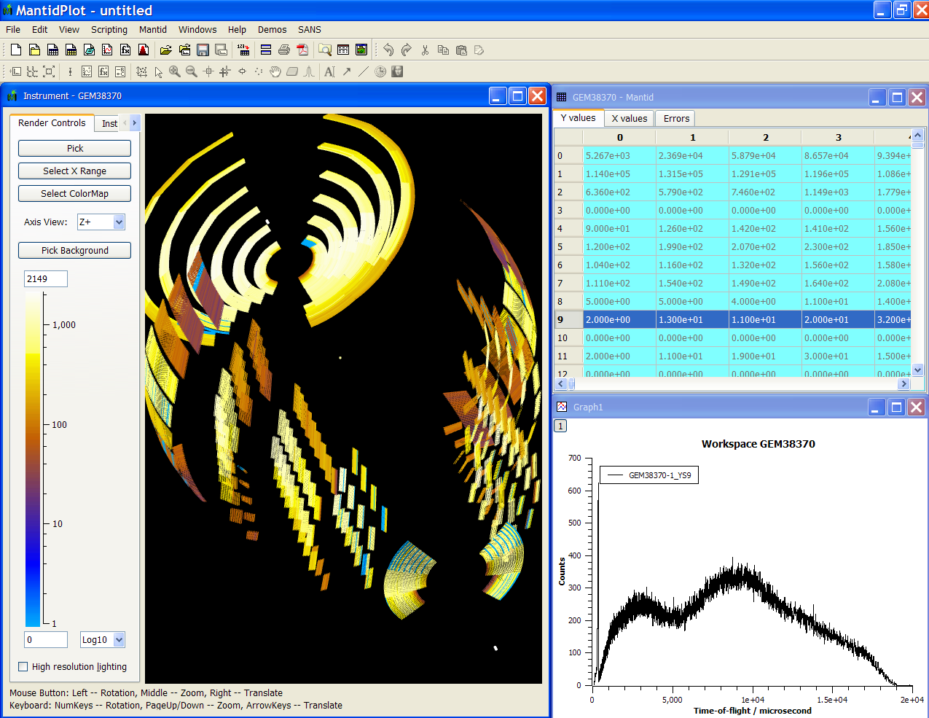
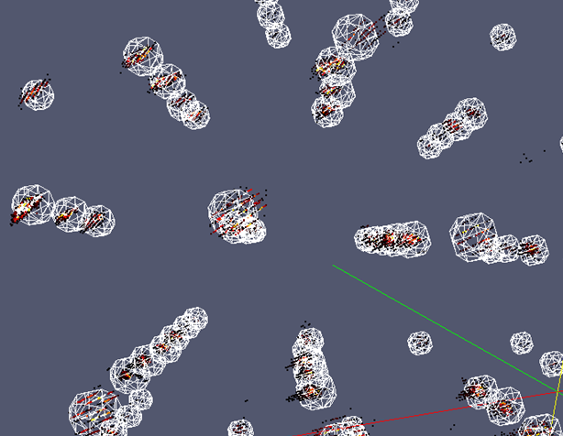
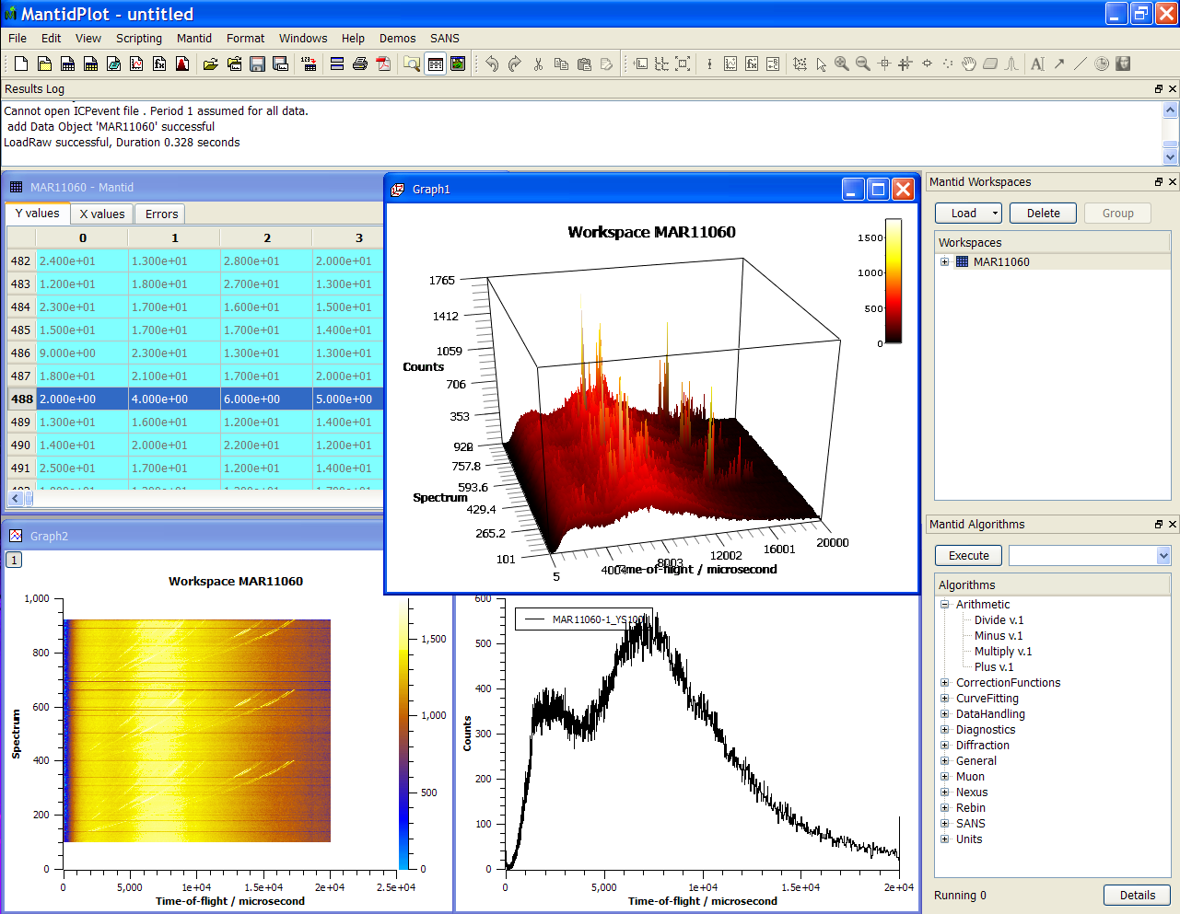
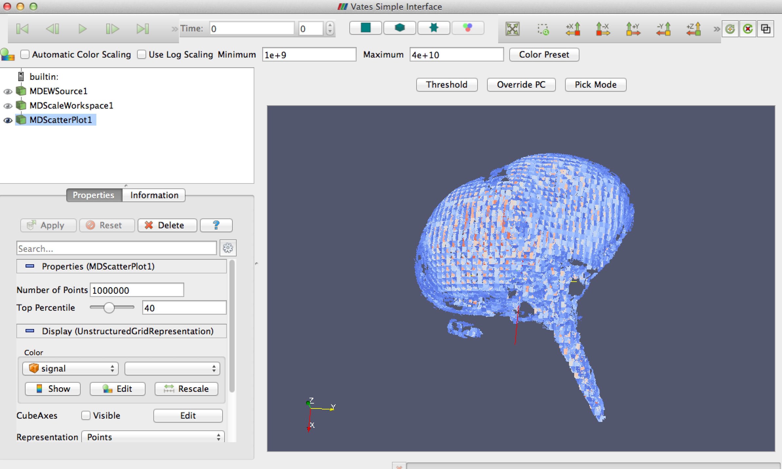
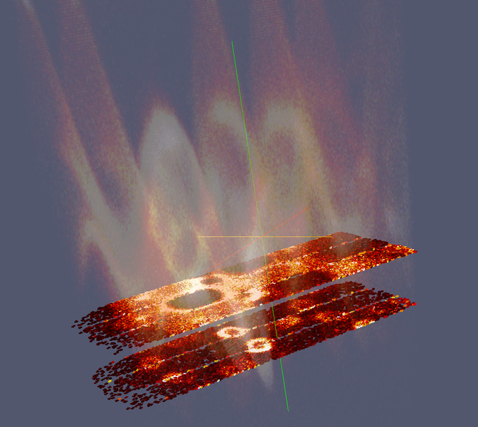
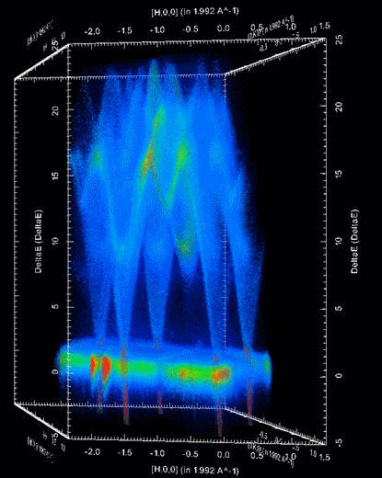

Document Control
This document is under document control. All members of the distribution list will receive updated copies whenever alterations are made. All other copies are uncontrolled.

Contributors
Name | Role | Company
Nicholas Draper | Author | Tessella

Document Approval
Name | Role | Company

Distribution
Name | Role | Company
Project Management Board Members | Recipient | STFC & ORNL
Mantid Project Repository | Filing | STFC & ORNL

Revision History
Author | Issue | Date | Description
Nicholas Draper | V1.R1.M0 | 28-May-2015 | 1st version written

References
Document | Ref | Date | Details and Version
Project Specification | [PS] |  | https://github.com/mantidproject/documents/blob/master/Project%20Management/ProjectSpecification.doc?raw=true
Stakeholder Plan | [SP] |  | https://github.com/mantidproject/documents/blob/master/Project%20Management/StakeholderPlan.doc?raw=true
Risk Register | [RR] |  | https://github.com/mantidproject/documents/blob/master/Project%20Management/RiskRegister.xls

Table of Contents
1 Introduction 3
2 Minutes of the previous meeting 4
3 Project Documentation 4
4 Project Status 4
5 Usage of Mantid in various Environments 6
6 Interest from Other Facilities 7
7 Future Release Dates 7
8 Appendix A: Metrics 8

Introduction

Purpose of this Document
This report details the current state of the Mantid project and presents the agreed agenda for discussion. The project management board will use the information in this report as a basis for the meeting.

Scope of this Document
The scope of this document is limited to the Mantid project, both for progress up to the meeting of the Project management board, and plans for the future.

Context of this Issue
This is the sixteenth project management report to the Mantid project management board and will provide input to the meeting.

Minutes of the previous meeting
The minutes of the previous meeting are available here:
https://github.com/mantidproject/documents/blob/master/Project-Management/PMB/Minutes/PMBMinutes29thMay15.docx?raw=true

Project Documentation
The project documentation is available through the links below. The documents have not been changed since the last PMB meeting.

Stakeholder Plan:
https://github.com/mantidproject/documents/blob/master/Project%20Management/Stakeholder Map.doc?raw=true
No changes this time

Risk Register:
https://github.com/mantidproject/documents/raw/master/Project-Management/RiskRegister.xls

No changes this time

Project Status

Development Progress
Since the last PMB meeting in January 2015 we created one full release and a patch release is immenent:
- Release 3.5 06-Oct-2015
- Release 3.5.1 23-Nov-2015
Development continues at a good pace: see the project metrics in section Error: Reference source not found.

Update on progress of SSC requirements

Completed in Release 3.5
id | summary | status | owner
#12172 | Add Note | closed | Elliot Oram
#12074 | Enhancment for Vesuvio | closed | Martyn Gigg
#12069 | Documentation/Consistency for input parameters e.g. workspace index vs spectrum number | closed | Nick Draper
#12064 | Check Mantid Version on Startup | closed | Nick Draper
#10149 | Tools to help compare models to data | closed | Roman Tolchenov
#6457 | SANS: Assess & rectify zero errors in ISIS SANS data | closed | Anton Piccardo-Selg

Usage of Mantid in various Environments
We currently fully support the following environments:
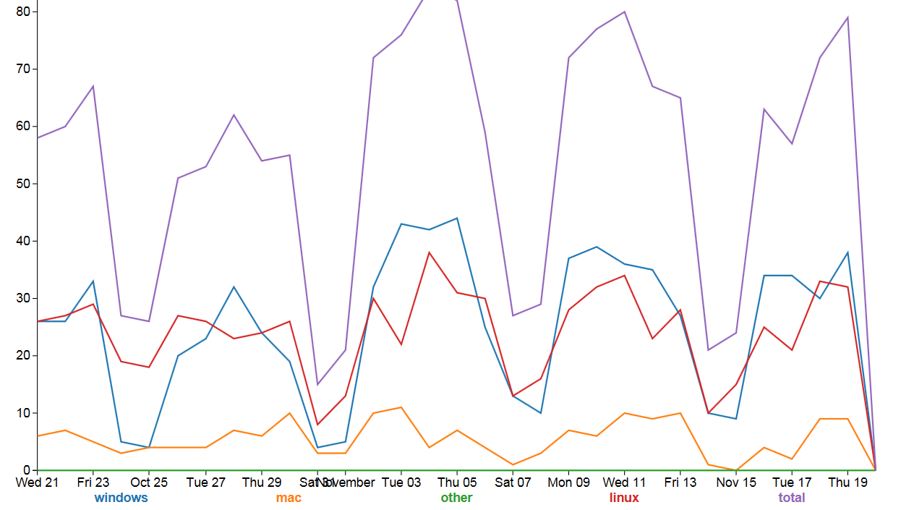
- RHEL 6 64bit
Total
Linux
Windows
Mac
- RHEL 7 64bit
- Windows 7 64 bit
- Ubuntu LTS 64 bit
- OS X 10.9 Mavericks+
Limited Support:
Windows 8 64 bit
Fedora 20

No support – but apparently works:
Windows 10

Current Usage:
http://reports.mantidproject.org/
Looking over the last month we have a similar number of active Linux and windows pcs running Mantid, between 20-40 machines running each on a normal weekday. The number of Macs is much lower with a peak of about 10 per day.

Interest from Other Facilities

ILL
Mark Johnson has advertised for 3 developers to work on Mantid, is interviewing at the end of January, and is planning on starting the team up towards the end of Q1 2016.

Others
We have previously invited other groups to the Mantid developer meeting. I was planning on doing this again, who should I contact?
- Mark Johnson, ILL
- Nick Hauser, David Mannicke, ANSTO
- Junrong Zhang, CSNS
- Mark Könnecke, PSI
- Joachim Wuttke, FRM II and JCNS
- Peter Willendrup, McStas

Future Release Dates
The planned release dates for the future are:
v3.6 15th February 2016
This does not include patch releases.

Appendix A: Metrics

Project Metrics
The code metrics are independently generated and displayed here
http://www.openhub.net/p/Mantid/analyses/latest/languages_summary
Total Lines : | 3,015,269 |  | Code Lines : | 2,279,583 |  | Percent Code Lines : | 75.6%
Number of Languages : | 20 |  | Total Comment Lines : | 419,536 |  | Percent Comment Lines : | 13.9%
 |  |  | Total Blank Lines : | 316,150 |  | Percent Blank Lines : | 10.5%

- In a Nutshell, Mantid...
- has had 51,426 commits made by 107 contributors
representing 2,279,583 lines of code
- is mostly written in C++
with an average number of source code comments
- .has a well established, mature codebase
maintained by a very large development team
with increasing Y-O-Y commits
- took an estimated 647 years of effort (COCOMO model)
starting with its first commit in April, 2007
ending with its most recent commit 3 days ago

